Middleware: Ludo game

Group 4

Jean Chan  
Loic Motheu  
Hristo Tarnev

Design document

Contents

Architecture diagram 3

Description of Interfaces 4

Methods 4

ILudo 4

IChat 4

Callbacks/Events 4

ILudoCallBack 4

IChatCallback: 4

Class diagram 5

Sequence diagrams 6

# Architecture diagram

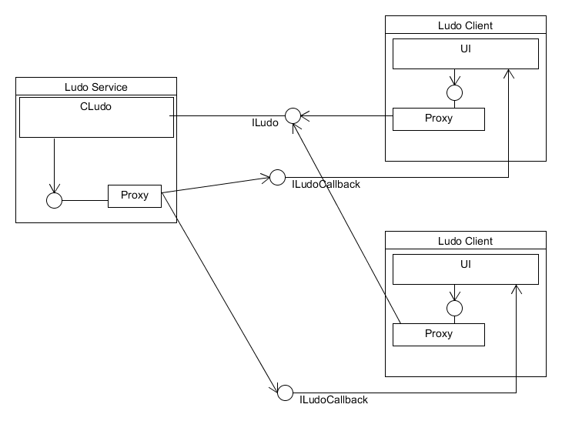

# C:\Users\Loic\Dropbox\MDW\Design\Chat.png

# Description of Interfaces

## Methods

### ILudo

This interface handles all of the player actions during a game.

*//Should we make a void InitializeBoard() that places all tokens into base and lets player 1 start?*

Void RollDice(): Generates a random number between 1 and 6. <<If we want to display the roll result to other players, would we need a callback operation as well?>>

void MoveToken(Token token, int diceRoll): Moves a desired token x amount of squares where x is the dice roll.

void PlaceToken(Token): When a user rolls a 6, he may place a token on the starting square.

List<Players> PlayerReady(Player player): Marks a player as ready to play

void ChooseColor(Player player): Allows a player to choose a color.

### IChat

Handles the chatting between players

Void SendMessage(String message, List<Player> players): Can be both public and private, by sending a string message to all players available in the current game, or to a specific player.

## Callbacks/Events

### ILudoCallBack

Handles the notifying the changes within the game to other players.

void PlayerTurn(Player player): Indicates who’s player turn it is.

void TokenMoved(Token token, int diceRoll): When a player has moved a token, now all the

*// Should we notify the opponents when a player places a token into play or when a player wins a game?*

void StartGame(List<Player> players): Needs a list of players who are ready to be able to start the game.

### IChatCallback:

Handles the notifying the other players of the chat messages.

String ReceiveMessage(): Returns the message written by other players.

# Class diagram

Note: We were unsure whether we needed to have a class diagram for the overall project, of for just the WCF components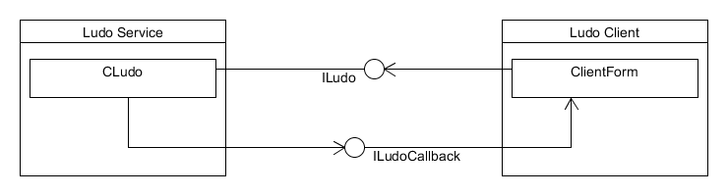

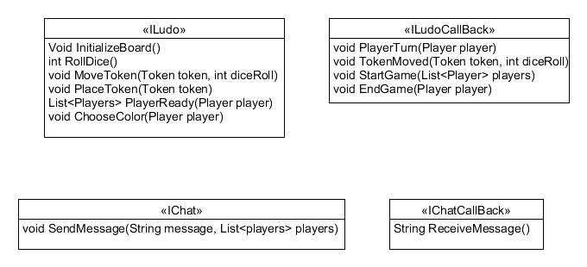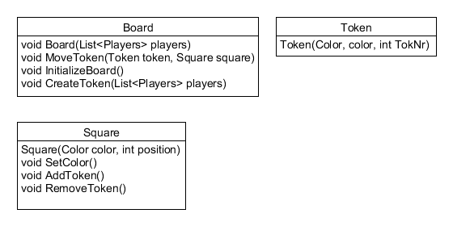

# Sequence diagrams

